Exercise 2 – Create markdown cell with title of the notebook.

Screen shot:

2-title.png

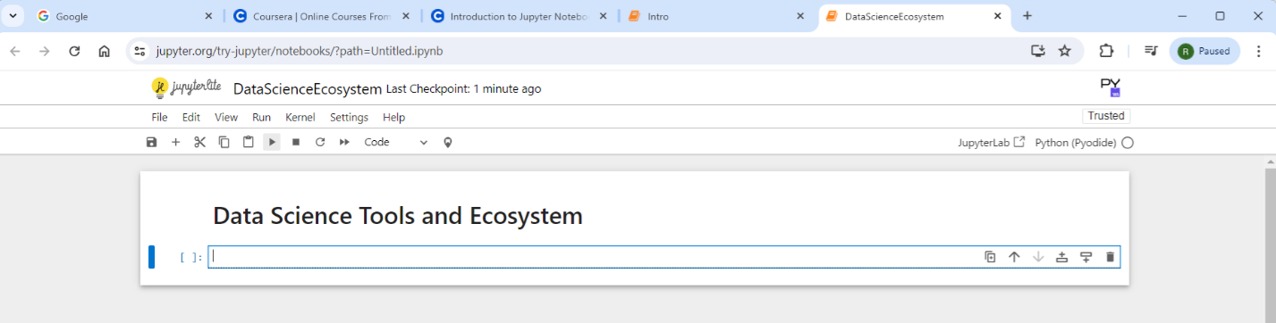

Exercise 3 – Create a markdown cell for an introduction

3-intro.png

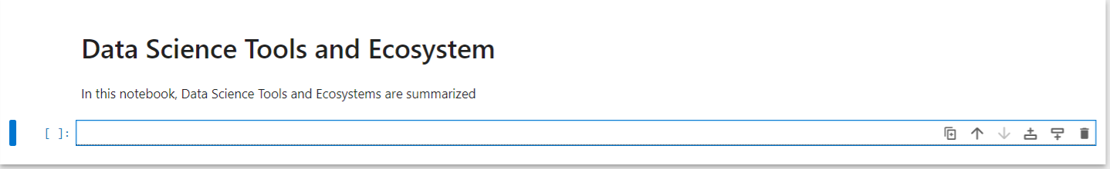

Exercise 4 – Create a markdown cell to list data science languages

4-dsLanguages.png

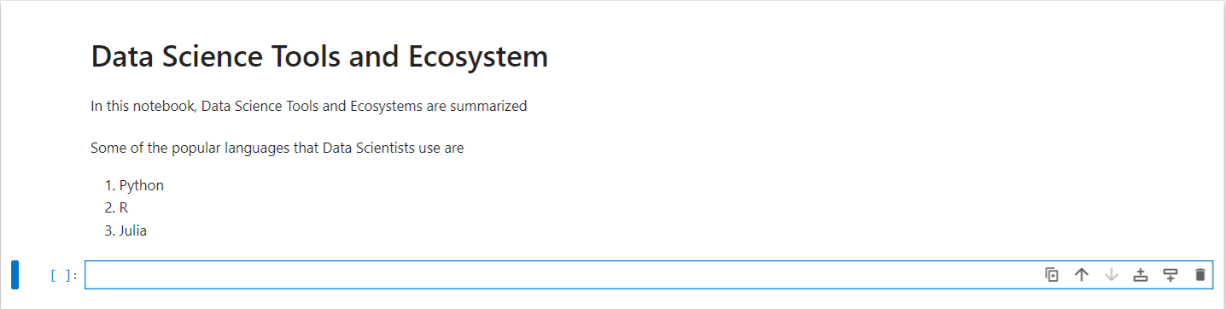

Exercise 5 – Create a markdown cell to list data science libraries

5-dsLibraries.png

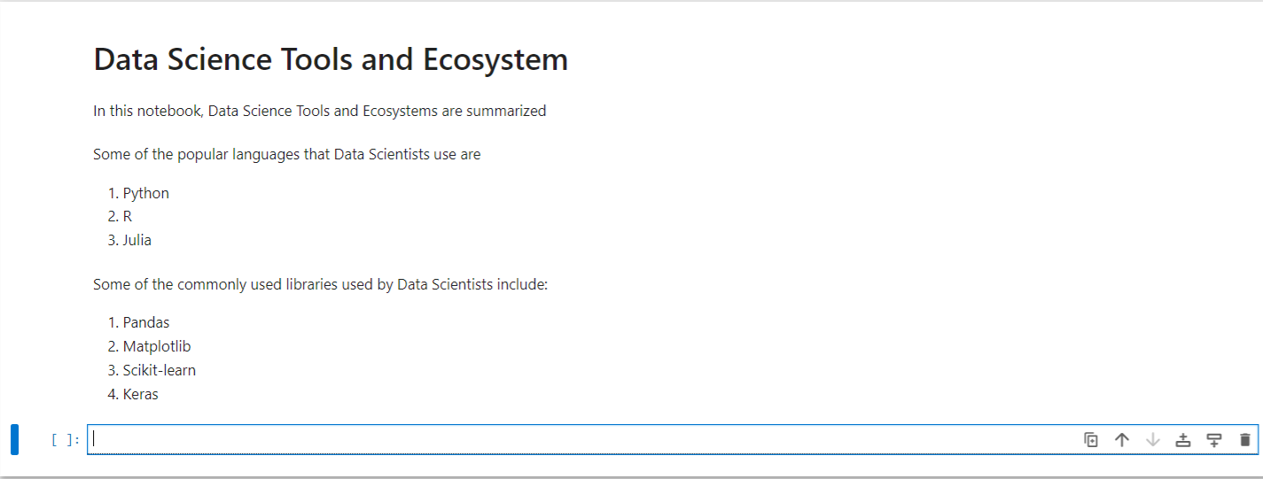

Exercise 6 – Create a markdown cell with a table of Data Science tools.

6-dstools.png

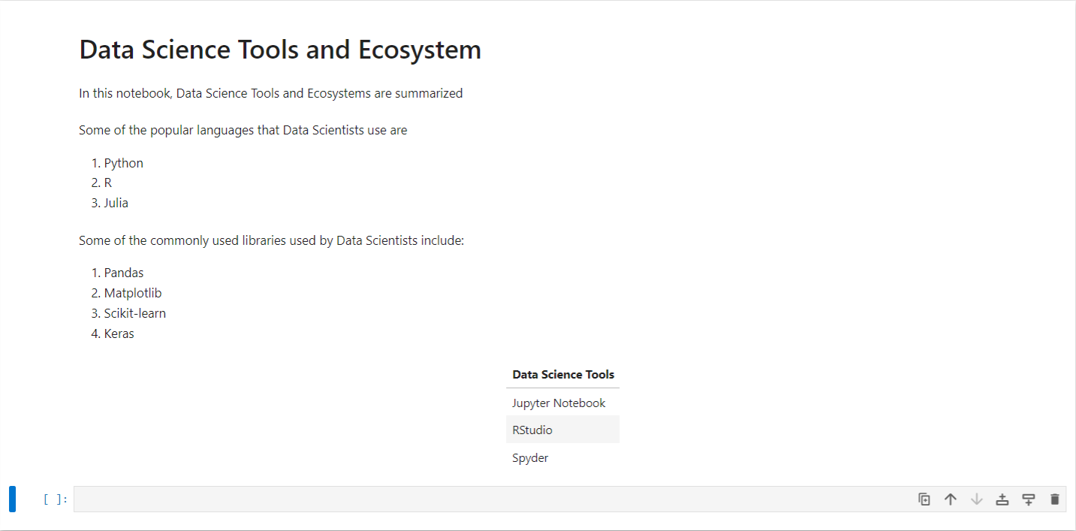

Exercise 7 – Create a markdown cell introducing arithmetic expression examples

7 – introarithmetic.png

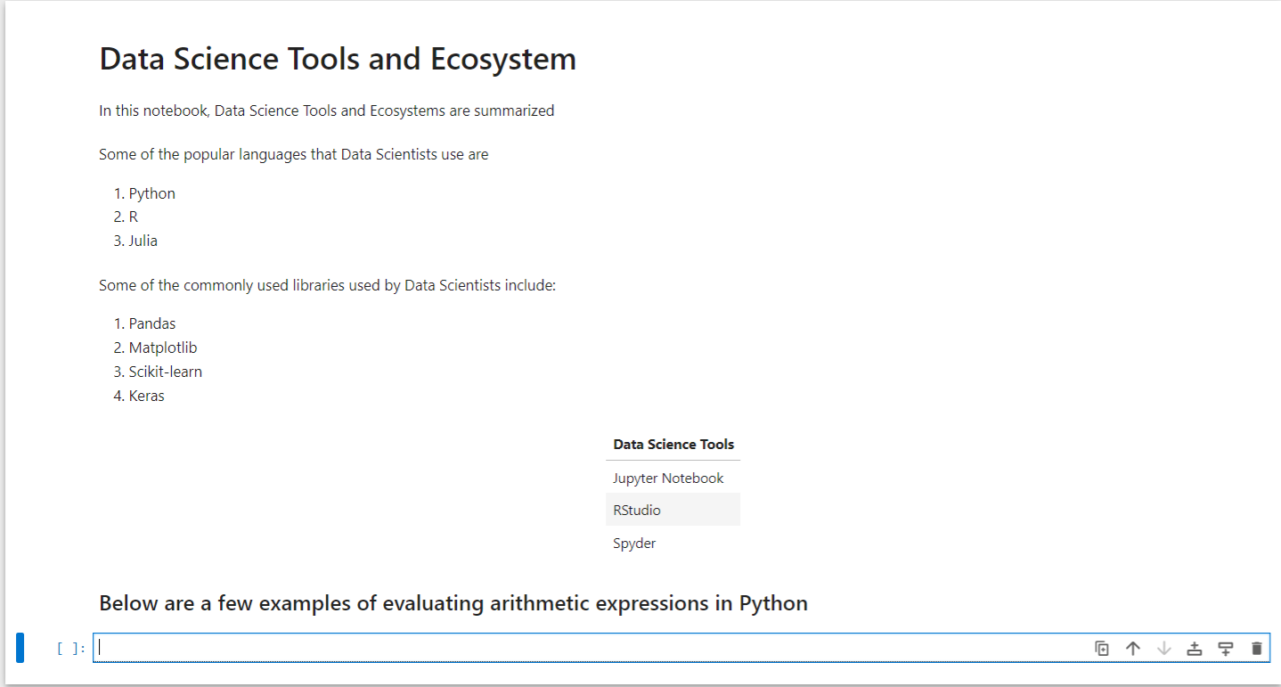

Exercise 8 – Create a code cell to multiply and add numbers

8-multiplyandaddintegers.png

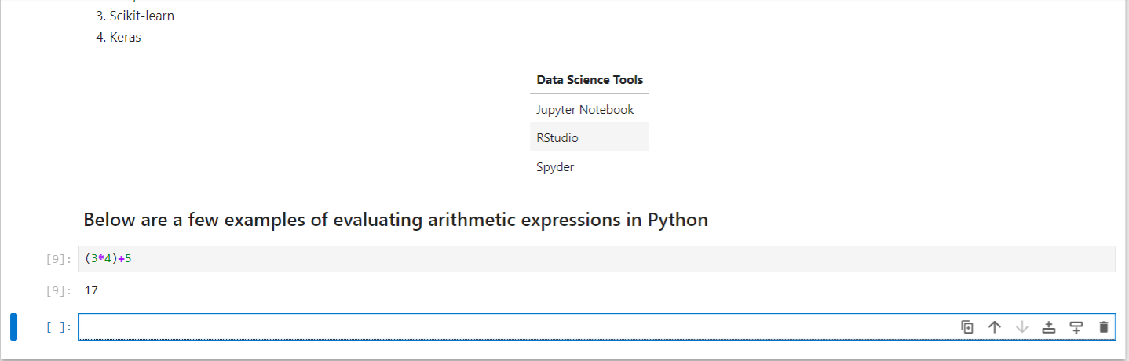

Exercise 9- Create a code cell to convert minutes to hours

9-hourstominutes.png

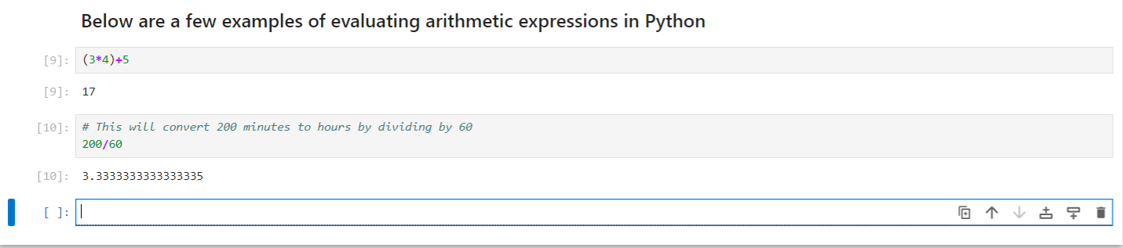

Exercise 10 – Insert a markdown cell to list Objectives

10-objectives.png

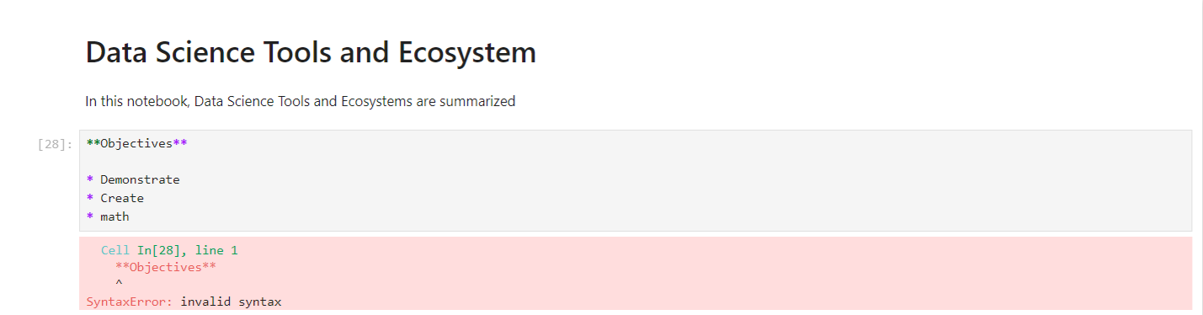

Note: this code doesn’t work – see also the example from the training session:

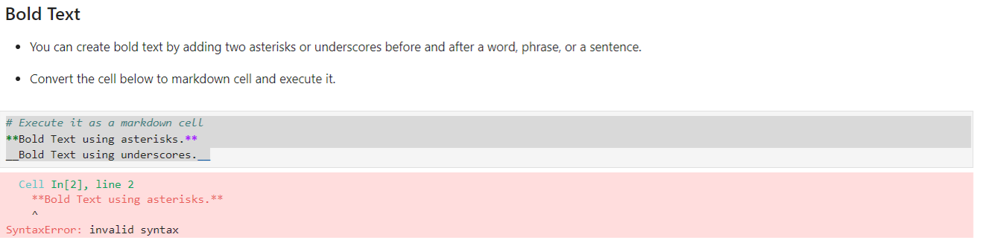

Exercise 11 – Create a markdown cell to indicate the Author’s name

11-authordetails.png

